**Project Design Phase-II**

**Data Flow Diagram & User Stories**

|  |  |
| --- | --- |
| Date | 01 November 2023 |
| Team ID | NM2023TMID04504 |
| Project Name | Creating an Email Campaign in Mailchimp |

**Data Flow Diagrams:**

A Data Flow Diagram (DFD) is a traditional visual representation of the information flows within a system. A neat and clear DFD can depict the right amount of the system requirement graphically. It shows how data enters and leaves the system, what changes the information, and where data is stored.

**Data Flow diagram :**

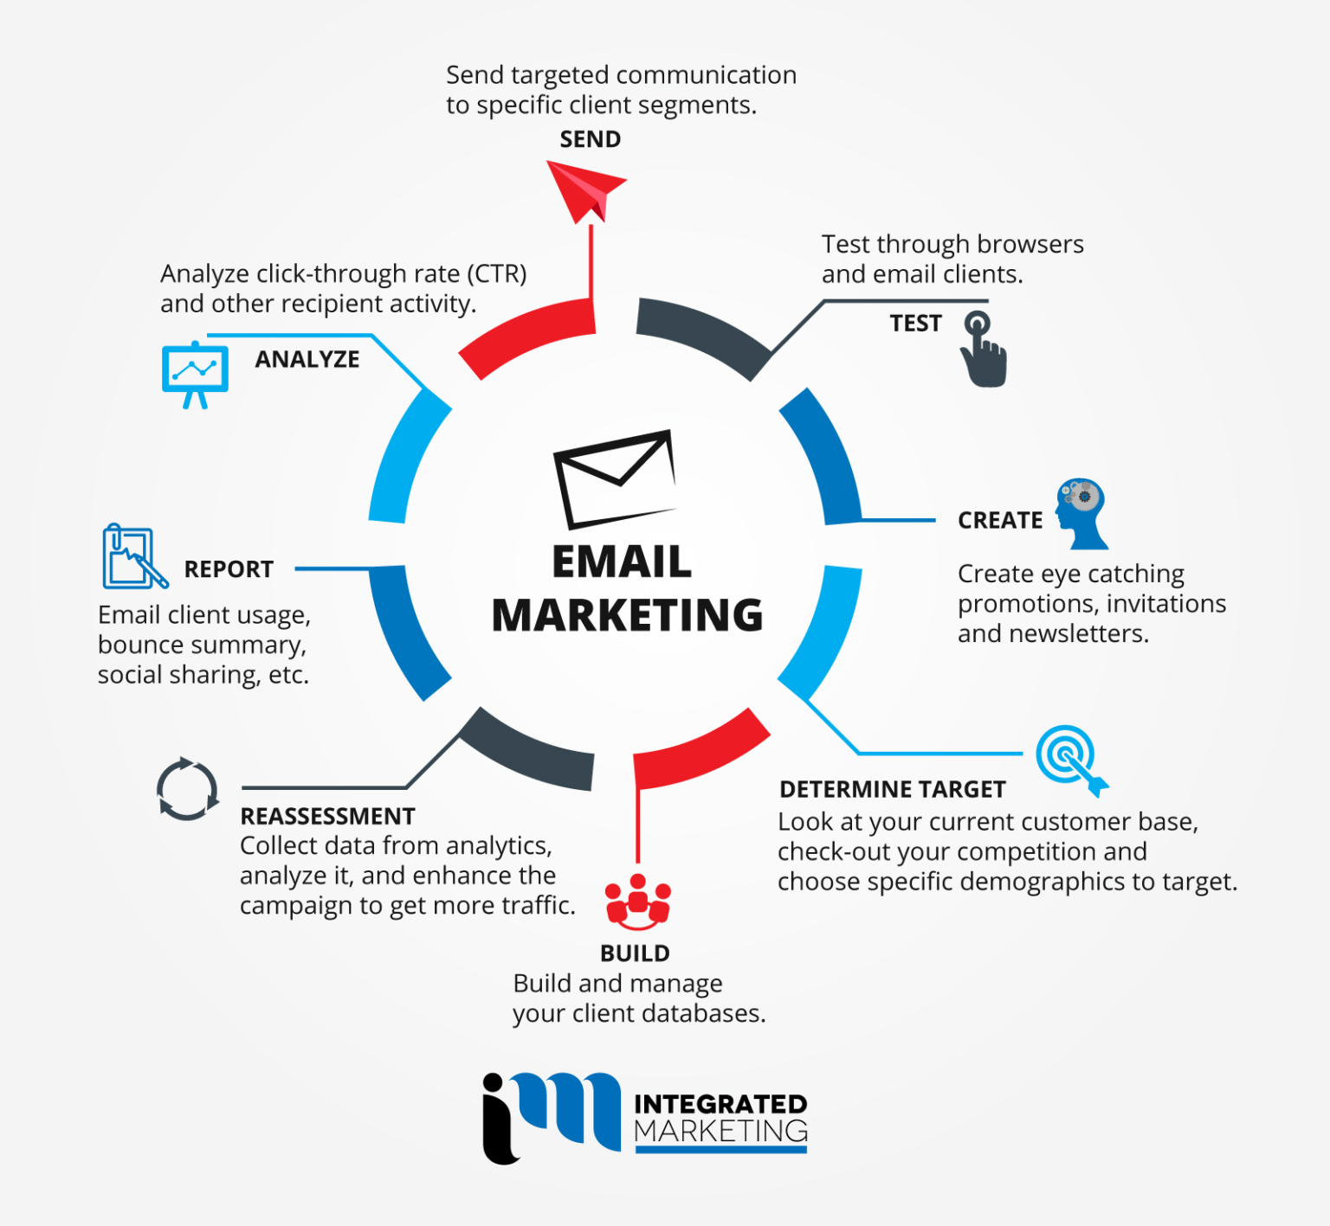

**User Stories**

|  |  |  |  |  |  |  |
| --- | --- | --- | --- | --- | --- | --- |
| **User Type** | **Functional**  **Requirement**  **(Epic)** | **User Story Number** | **User Story / Task** | **Acceptance criteria** | **Priority** | **Team Member** |
| Marketing Manager | Email Campaign Creation and Management | USN-1 | As a marketing manager, I want to create and send an email campaign to promote our latest product to our subscribers effectively... | The system allows the marketing manager to log in with their MailChimp account. | High | Hasan sheriff |
| Subscriber | Personalized Email Content | USN-2 | As a subscriber, I want to receive personalized email content that is relevant to my interests to increase engagement and potential purchases. | The system collects and utilizes subscriber data, including preferences, past interactions, and demographic information. | High | Maheshwaran |
| MailChimp user | Custom Email Templates | USN-3 | As a MailChimp user, I want to design and use custom email templates to ensure our campaigns have a consistent look and feel. | The MailChimp user can access the email template editor within the system. | Medium | Sanjay |
| Compliance Officer | Data Protection and Compliance | USN-4 | As a compliance officer, I want to ensure that all email campaigns adhere to data protection laws and provide mechanisms for subscribers to manage their preferences. | The system provides a user interface for compliance officers to review and approve email campaigns. | High | Dharanitharan |
| Data Analyst | Performance Metrics and Analytics | USN-5 | As a data analyst, I want to access performance metrics, including open rates, click-through rates, and conversion rates, to measure the success of email campaigns and make data-driven improvements. | The system provides a dashboard with performance metrics for each email campaign.. | High | Maheshwaran |
| IT Administrator | Account Security and Administration | USN-6 | As an IT administrator, I want to ensure the security of our MailChimp account by implementing role-based access control and maintaining secure login credentials. | The system provides role-based access control to limit access to authorized team members. | High | Sanjay |